Hotel Tech Benchmark: Reputation and Review Management 2023
January 2023

Report Overview
Guest feedback, which was initially gathered through comment cards in hotel rooms, was disrupted by the explosive popularity of online guest reviews across a wide range of public platforms. Some hotels still continue to use guest satisfaction surveys to help benchmark guest satisfaction. Reputation and review management has guest satisfaction at its core. With hotels heavily investing in creating great experiences and aiming to provide impeccable service, it is equally important to observe whether their efforts align with the perception of the consumer.
As customer experience has become more digitized, hotel guests are now empowered to share their opinions and experiences on third-party platforms such as Tripdadvisor, Google, booking sites like online travel agencies (OTA), and social media. Reputation and review management software facilitates the monitoring and evaluation of these reviews and ratings, thus managing how a hotel is perceived publicly. It helps quantify guest satisfaction and highlight areas for improvement or opportunity.
Reputation and review management software has diverse offerings such as tracking what is said about the business on multiple platforms, getting live feedback using QR codes or WiFi login pages, sending post-stay surveys to guests, optimizing the hotel website to show positive reviews, and sharing reports and benchmarks for performance tracking.
Data in this report is accurate as of December 2022. For the latest updated information, Skift Research subscribers can access our Hotel Tech Benchmark dashboard, which is updated
periodically as we collect more data from hotel tech vendors.

What You'll Learn From This Report
- Current and future growth potential of Reputation and Review Management Software
- Total market penetration
- Top Vendors market penetration
- Revenue distribution for vendors
- Total market penetration for vendors based on total number of hotels and rooms they service

Importance of Reputation Management
Guest feedback is a strong measure of understanding a guest’s satisfaction with hotel services, and is closely monitored by many hotels as a Key Performance Indicator (KPI) to guide areas of improvement. In the age of digital word-of-mouth, reputation and review management plays a vital role in a hotel’s success strategy. While hotel pricing and offerings are the main drivers for a guest choosing to book a hotel, guest reviews are a critical contributor to this decision. Studies show that 95% of travelers read reviews before booking a hotel and 85% of consumers trust reviews as much as personal recommendations.
A recent report by Revinate, a popular hospitality tech vendor, suggests that hotels using their reputation and review management software observed a 15% increase in Tripadvisor ranking and a 409% increase in review volume. Reputation and review management systems help with monitoring and analyzing guest reviews across review sites. They consolidate reviews creating a proprietary score which helps guests get a holistic view of a hotel’s offerings, and helps hoteliers with benchmarking guest satisfaction. They optimize websites by pushing positive reviews and manage reputation using a ticketing system to flag negative reviews, which can then be responded to. Harvard Business Review’s analysis on Tripadvisor reviews shows that hotels that responded to guest reviews received 12% more reviews and their ratings increased by 0.12 stars. Analysis of guest surveys gives insights on the key drivers of guest satisfaction for the hotel and areas that require improvement.
Hotel bookings are now largely digital, which highlights the importance of managing online reputation. Good reviews and ratings translate into higher sales volumes. Integration with other systems has helped hotels seize this opportunity.

Reviews for Revenue Growth
TrustYou’s partnership with IDeaS, a revenue management software, involves adapting the revenue management strategy to data insights gathered from reviews. TrustYou’s Q3 2022 analysis shows that Price as a category contributed the most to hotels being reviewed negatively, for the first time ever. The company aims to provide a solution to hotels where reputation data can be incorporated into IDeaS’ pricing analytics to drive revenues and price the product based on perceived value.
Cloudbeds is one of the property management systems (PMS) that facilitates integration with multiple reputation and review management systems such as Reputize, myHotel, GuestRevu, TrustYou, and RepUp. Reputation and review management software helps hotels capture real time feedback using emails or using tablets, thus reducing the chance of negative post-stay reviews. Integrating with a PMS that contains guest data, facilitates this. GuestRevu enables hotels to use automated guest surveys tailored to the guest depending on their stay. This helps build guest profiles and stay history. RepUp’s solution allows generation of higher sales volumes by increasing rankings. Cloudbeds suggests that the integration has helped drive hotel revenues up by 20% through customized upsells, repeat bookings, and guest loyalty.

Significant Unused Market Potential
Reputation and Review Management software has gained popularity in the last decade. At Skift Research, we estimate that Reputation and Review Management software vendors in the hospitality industry generated a total revenue of $559 in 2019. Combining this with the unused market potential, this tech category has the potential to generate a total of $1.3 billion in annual revenues.
These revenues are estimated on the basis of pricing information available through vendor surveys and websites. The average price paid by hotels is multiplied by the estimated total number of hotels and rooms worldwide. Further information on the methodology used can be found at the end of this report.
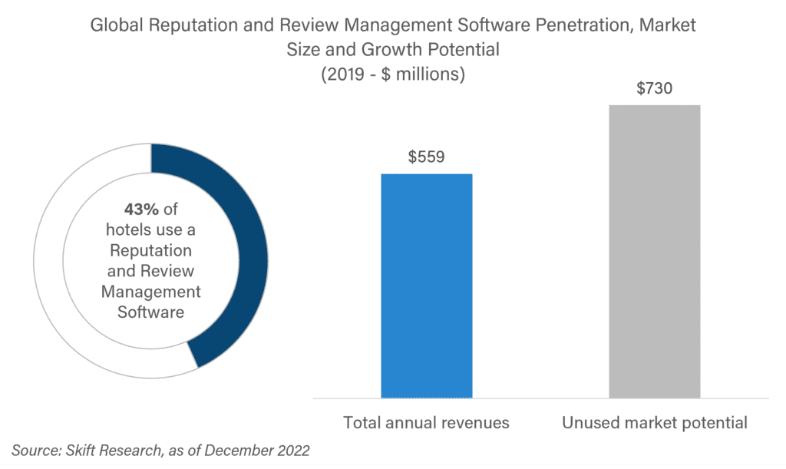
We estimate that 43% of hotels globally use reputation and review management software to manage guest feedback. This space is dominated by some of the most popular vendors such as TrustYou, ReviewPro, and Medallia.

Top Vendors Dominate
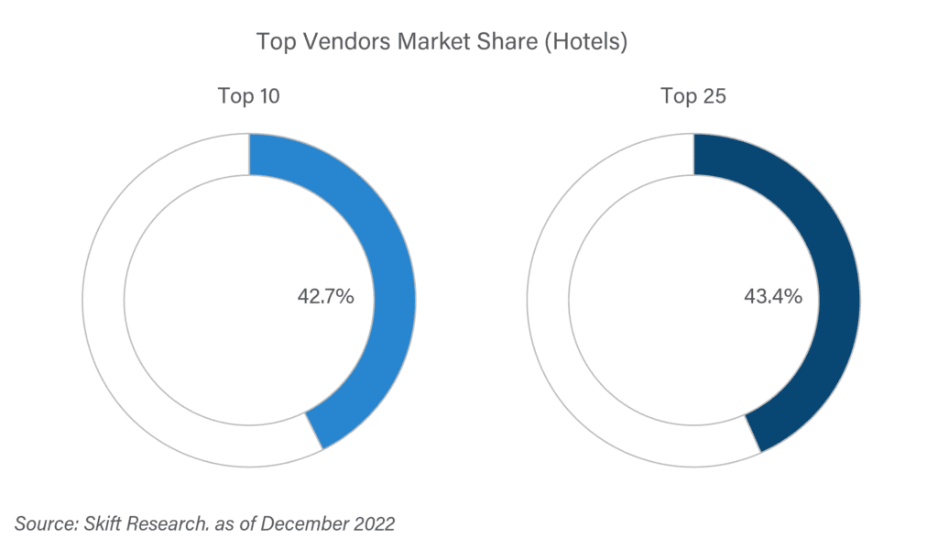
Our analysis includes market penetration of 18 reputation and review management software vendors. The top 10 players account for 98% of the total share of hotels that have this software as a part of their tech stack.
Large players have a leg up, since the software needs to be agile and quick in terms of gathering real-time reviews, therefore needing considerable investment in computing power. Furthermore, as the system needs to pull data from a plethora of different systems, vendors need to be well integrated, and hotel chains tend to prefer to use the same software across all their hotels.

Revenue Streams
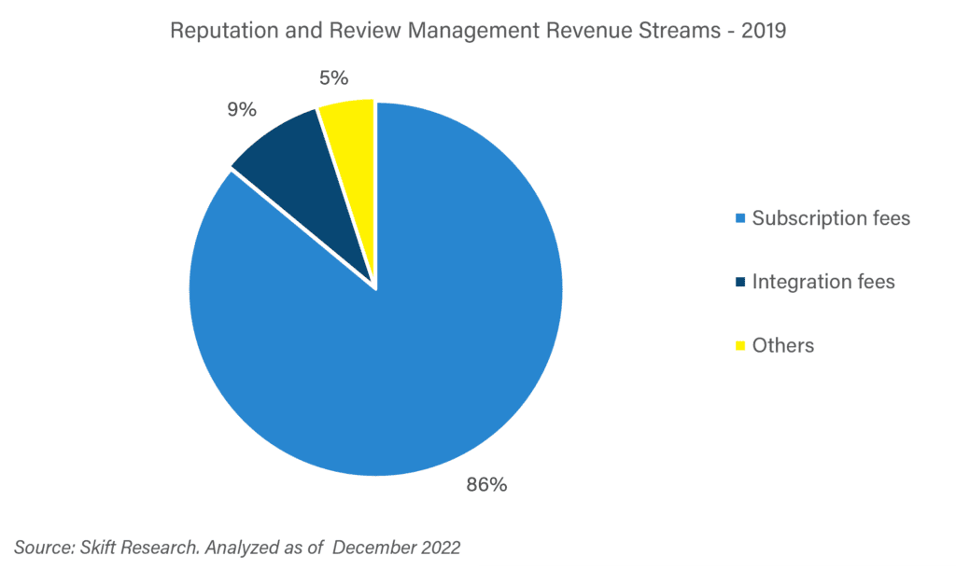
Reputation and review management software fees range from $50 to $500 a month. They work with a SaaS (Software as a Service) model where they primarily monitor and report reviews for a set subscription fee. The pricing range is high since vendors tend to offer tiered pricing packages from Basic to Enterprise or Custom Pricing where the latter provides a more holistic reputation management strategy. Subscription fees therefore account for 86% of the total revenue generated.
Integration fees contribute to 9% of revenues. This includes integrating data gathered through various channels with other existing hotel systems to gain insights into consumer behavior, preferences, and guest satisfaction across various touch points through the guest’s hotel journey. Some software also provides the ability to customize surveys per guest. Integrating with a Revenue Management System helps hotels in maximizing revenues.
Some vendors use a more À la carte pricing strategy. The base subscription fee is lower than others, but they charge for additional services such as emailing surveys. Hoteliers may choose the number of surveys to be emailed and are charged accordingly.

Vendor List
 | Vendors | Base | Hotels | Hotel Share | Rooms | Room Share
1 | TrustYou | Germany | 100,000 | 16.7% | 5,000,000 | 16.7%
2 | ReviewPro | China | 60,000 | 10.0% | 3,000,000 | 10.0%
3 | Medallia | U.S. | 40,000 | 6.7% | 2,000,000 | 6.7%
4 | D-Edge | France | 18,000 | 3.0% | 900,000 | 3.0%
5 | STAAH | New Zealand | 13,000 | 2.2% | 650,000 | 2.2%
6 | Revinate Guest Feedback | U.S. | 12,000 | 2.0% | 960,000 | 3.2%
7 | BirdEye Inc. | U.S. | 5,000 | 0.8% | 250,000 | 0.8%
8 | Customer Alliance | Germany | 3,500 | 0.6% | 175,000 | 0.6%
9 | Qualitelis | France | 2,500 | 0.4% | 125,000 | 0.4%
10 | Guest Suite | France | 2,000 | 0.3% | 100,000 | 0.3%
11 | Flexkeeping | UK | 1,110 | 0.2% | 55,500 | 0.2%
12 | Qualitando | Italy | 800 | 0.1% | 40,000 | 0.1%
13 | Reputize | UK | 800 | 0.1% | 40,000 | 0.1%
14 | Duve | Israel | 700 | 0.1% | 45,000 | 0.2%
15 | BookLogic Hotel Review & Reputation Management | Turkey | 500 | 0.1% | 25,000 | 0.1%
16 | Glitch by Nuvola | U.S. | 154 | 0.0% | 51,214 | 0.2%
17 | Instio Platform – Review Management | India | 120 | 0.0% | 4,000 | 0.0%
18 | RepUp | India | 105 | 0.0% | 605 | 0.0%
 | TOTAL |  | 260,289 | 43.4% | 13,421,319 | 44.74%

Hotel Tech Benchmark Methodology
The Hotel Tech Benchmark by Skift Research is based on a mix of information provided by hotel tech vendors and proprietary data calculations. Participating companies have provided extensive information about their operations, including:
- Historic and current revenues
- Revenue Streams
- Historic and current employee count
- Geographic Coverage
- Product breakdown, including software functionality, launch date, pricing models, and integrations
- Number of hotels and rooms per product
Market sizes and market potential are calculated bottom-up, using information from vendor input as well as publicly available information on company websites and in franchise disclosure agreements.
The total size of the hotel industry, which informs our ability to calculate market sizes, is a point of contention in the industry. We have used industry sources and our own estimates to determine the size of the hotel industry in terms of hotels and rooms.
There are many estimates of the number of hotels in the world, ranging between half a million and a million. We collected information from different sources to estimate the TOTAL NUMBER OF HOTELS WORLDWIDE AT 600,000.
This is much higher than the often-quoted STR figure, which is below 200,000. The STR estimate excludes properties with less than 10 rooms, and while known for its strong coverage of highly branded markets like the U.S., struggles to capture more independent markets in Europe and Asia.
Therefore, other sources were taken into consideration. Euromonitor International, a market research company which includes coverage on independent and chained hotels for 100 countries, estimates the market is just short of 600,000. Expedia asserts it has more than 600,000 properties on its platform, although this is likely to include more than just hotels.
Data on the number of rooms also shows extreme differences between sources. STR asserts that the average hotel has 92 rooms, while Euromonitor International puts this figure at 55. As both disregard small properties to different degrees, with STR particularly having limited coverage of independent and smaller hotels, we estimate that the average hotel has 50 rooms, to TOTAL 30 MILLION ROOMS WORLDWIDE.
Revenue streams are calculated using input from participating vendors, taking into account the size of each vendor and their revenue breakdown. As participation increases, this data is expected to change.

