Recession Watch: Hotel Chain Scale Analysis 2023
March 2023
timer 29 minutes

Report Overview
This report looks at hotel performance by chain scale in times of crisis and recession in the U.S., as well as the comparison of unit growth strategies of major hotel brands post the 2008/9 Great Financial Crisis versus their current pipelines.
The macroeconomic outlook for the U.S. in 2023 appears bleak – rising interest rates, squeezed consumer spending, and a looming recession. However, the hotel and travel sector remains optimistic, with tailwinds from the recovery of cross-border, group, and business travel, as well as a structural shift in consumer spending towards experiences, expected to boost the industry. There are still reasons for caution however, with the recovery pace slowing down versus 2022 and consumer spending taking a hit from depleted savings and lessened pent-up demand.
CEOs of major hotel brands predict a “moderate recessionary environment” in the back half of 2023 in the U.S., as said by Chris Nasetta, CEO of Hilton during Q4 2022 earnings. This may see plateauing of RevPAR (Revenue per Available Room) and ADR (Average Daily Rate) growth rates. Previous economic cycles can guide the industry on areas that will remain most resilient, such as midscale hotels, and why some chain scales, such as luxury, are expected to remain strong in a potential 2023 recession unlike what has been seen in prior downturns.
This report also dives into the development strategies of the major hotel brands, looking in particular at the white-space opportunities for future growth – notably the luxury space which has piqued investor interest through the pandemic, and also the premium economy segment which has seen a flurry of new brand launches in the last few months.

What You'll Learn From This Report
- How do different hotel chain scales perform in times of recession
- Why a potential recession in the U.S. in 2023 might be different to prior recessions
- Why the hotel industry can hope to stay optimistic in the face of economic uncertainty
- The development strategies of major hotel brands by looking at future hotel pipelines by chain scale, in particularly the luxury and premium economy segment

Executives Interviewed
- Alex Schellenberger – Chief Luxury & Premium Brands Officer, Accor
- Matt Schuyler – Chief Brand Officer, Hilton
- Dimitris Manikis – President & Managing Director EMEA, Wyndham

Executive Summary
Previous recessions have shown that the midscale segment tends to be the most resilient in times of economic downturns. Midscale hotels are at a lower price point than their upscale and luxury counterparts, meaning that they tend to outperform when there is down-trading during times of economic uncertainty, as consumer wallets get squeezed and disposable income decreases. Midscale hotels also appeal to many different types of travelers with varying reasons for travel, making them applicable to a large audience of consumers.
Though midscale tends to outperform other chain scales during economic downturns – and we expect it to again show resilience in a potential 2023 recession – we are cognizant of the fact that this recession is unlike any we have seen in the past. Further Covid recovery from business transient, group, and cross-border travel still offer tailwinds for growth, meaning that a recession in 2023 could be the first recession in the U.S. to see revenue per available room (RevPAR) RevPAR growth rather than RevPAR decline.
We also expect the luxury segment to show strength unlike what has been seen in previous recessions. Through 2022, we have seen that across the chain scale, luxury prices have risen the most versus pre-pandemic levels (luxury average daily rate (ADR) is +23% above 2019 vs industry average of +14% above 2019), but occupancy levels at luxury hotels are still the least recovered (luxury occupancy is -11% below 2019 vs industry average of -4%). There is therefore still scope for demand recovery in the luxury segment, which should see further price increases in line with demand growth.
Demand for luxury is expected to remain strong despite fears that Covid stimulus checks have been spent and consumer savings depleted, with consumer surveys showing that more than half of high income earners have seen their savings increase in 2023 vs 2022. This in addition to returning demand from international travelers, particularly those from Asia, provide further tailwinds for pricing expansion in luxury hotels. Having said that, as inflation levels moderate this year, we don’t expect the sky-rocketing levels of pricing growth seen in 2022, instead expecting growth rates to stabilize in the second half of 2023.
This report also analyzes the development pipelines of the branded players, particularly in the opportunistic luxury and premium economy space. In the period post the Great Financial Crash (GFC) in 2008/09, branded unit growth skewed to upscale and upper midscale hotels, whilst luxury growth stalled. However, as of January 2023, if we consider rooms under construction as a percentage of existing supply in the U.S., we can see that luxury hotels are being constructed faster than any other chain scale, spurred on by the outperformance of the luxury segment in 2022. Globally, branded luxury rooms account for 6% of the total branded supply across all the chain scales, but 8% of the pipeline, with majority of growth coming from luxury resort hotels in Caribbean & Mexico and from Asia Pacific. In addition to luxury, the other great whitespace opportunity is in midscale/premium economy and in recent months we have seen a flurry of new brand launches in this segment.

Comparing Hotel Performance in Times of Crisis
From a macroeconomic perspective, the outlook for 2023 in the U.S. seems bleak – rising interest rates, squeezed consumer spending, and a looming recession.
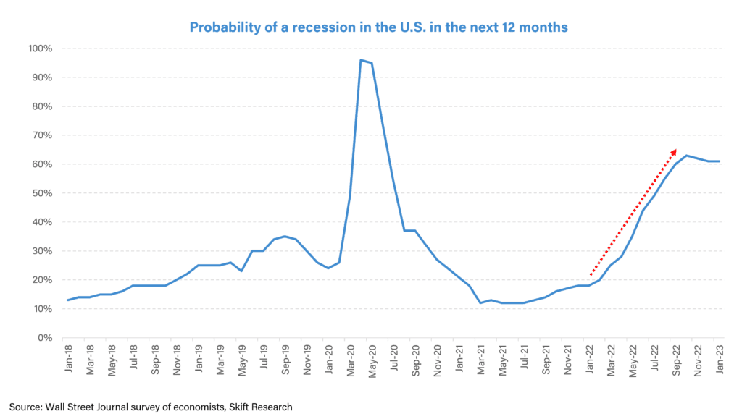
The hotel and travel sector however remains optimistic, as we have laid out in our Skift Research Global Travel Outlook 2023 report. This is based on further Covid recovery within international, group, and business travel, and a long-term shift in consumer spending from ‘things’ to ‘experiences.’ Matt Schuyler, Chief Brand Officer at Hilton says that, “As we look out over the resiliency of the consumer, we see that any type of discretionary money is finding its way towards experiences now. And that bodes well relative to a continued recovery in the travel sector and continued resiliency relative to macroeconomic conditions that may reduce spending in other sectors.”
However, there are reasons to be cautious, with the recovery pace slowing down in 2023 versus 2022, as regions like the U.S. and Europe largely recover to pre-pandemic travel levels and consumer spending takes a hit from depleted savings and lessened pent-up demand (as illustrated in our latest consumer sentiment tracker: U.S. Travel Tracker: December 2022).
Additionally, though the re-opening and recovery of outbound travel from Asia is a major tailwind for the global recovery, for most global hotel companies, the U.S. is still a bigger market than Asia, with Alex Schellenberger, Chief Luxury & Premium Brands Officer for Accor noting, “If the U.S. is hit [with a recession], some of that can be made up by the recovery from Asia, but not all of it.”
At full-year 2022 earnings, CEOs of major hotel brands such as Hilton guided to a “moderate recessionary environment” in the back half of 2023 in the U.S., which is likely to see plateauing of RevPAR (Revenue per Available Room) and ADR (Average Daily Rate) growth rates. It is therefore worthwhile to look back to previous economic cycles in the U.S. in order to gauge which areas of the hotel industry will remain most resilient in a potential recession. However we must also consider why a 2023 recession could be different to any other economic downturn we have seen in the past and why the industry can afford to be optimistic in the face of economic uncertainty.

Midscale Hotels Tend To Be Most Resilient During Recessions
In general, midscale and upper midscale hotels, i.e. hotels at a mid price point, tend to be the most resilient in times of recession, such as post 9/11 or the Great Financial Crisis (GFC), as shown in the three charts below – with midscale outperforming other chain scales in RevPAR, occupancy and ADR.
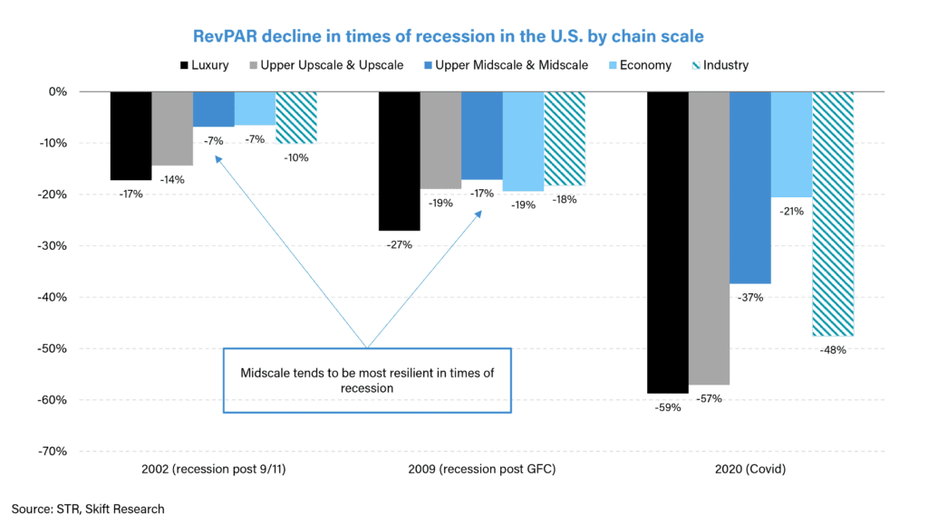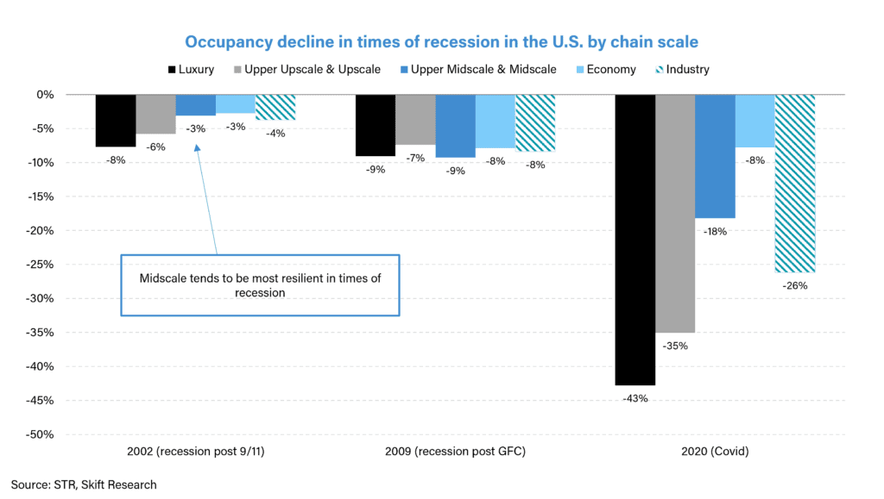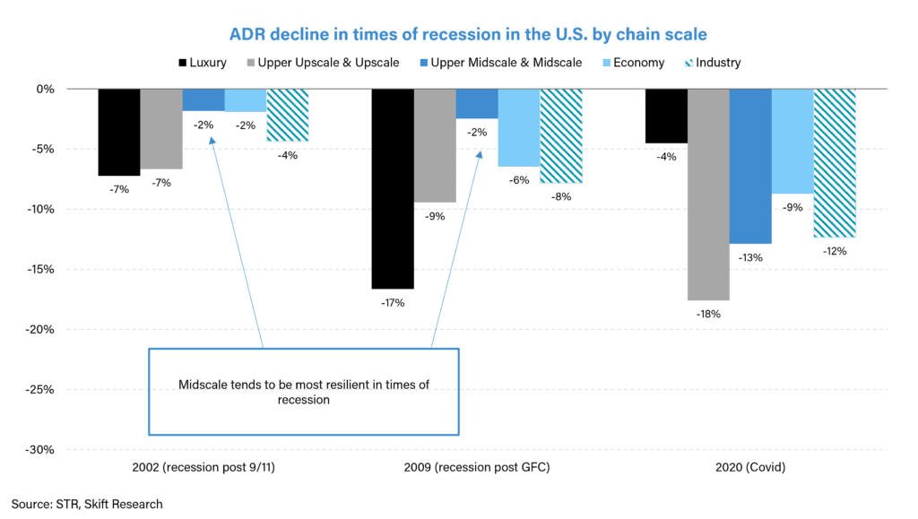
Midscale hotels are inherently at a lower price point than their upscale and luxury counterparts, as shown in the chart below, meaning that they tend to outperform when there is down-trading during times of economic uncertainty, as consumer wallets get squeezed and disposable income decreases.
We interviewed Dimitris Manikis, President EMEA of Wyndham Hotels – Wyndham, alongside Choice Hotels, are the most exposed to midscale amongst major hotel brands – who noted: “What makes the midscale segment extremely resilient is its price point and the value that it offers. It is affordable, good value for money, it’s in every location – tier one, tier two, tier three cities, you can find them in resort locations. It’s an honest proposition for consumers to enjoy.” We can see in the charts above that the main driver of midscale hotels’ outperformance is ADR, with midscale, being at a lower price point than its upscale counterparts, has lower to fall in a recessionary environment. This can be seen in the ADR chart above, which shows that midscale ADR only fell 2% both post 9/11 and the GFC, vs industry average of -4% decline post 9/11 and -8% during the GFC, respectively.
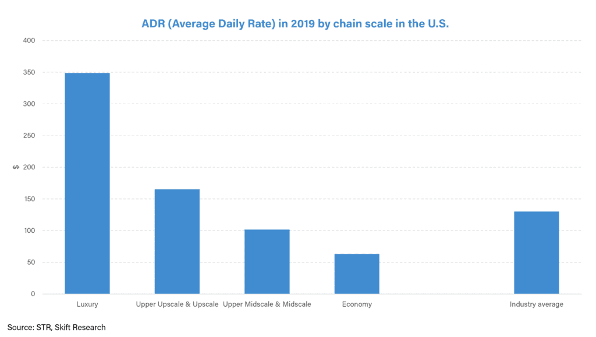
Midscale hotels also appeal to many types of consumers with varying reasons for traveling, with Manikis further adding that of the customer base who travel, “luxury travelers only account for eight to ten percent of the world. So ninety percent of the rest of the world is in every other segment [and thus] speaks to a bigger audience […] and you’ve got more midscale brands and midscale hotels around the world than anything else.”
This is reflected in hotel room count: as per hotel data provider STR, there are more midscale hotel rooms than any other chain scale in the U.S., with midscale and upper midscale brands accounting for 40% of rooms in the U.S. compared to just 3% for luxury and 20% for economy.
Additionally, during times of economic downturn, travel shifts to more domestic trips which midscale hotels benefit from since their customer base tends to be domestic travelers or those traveling for essential work. During 2020, we saw that mainstream midscale and economy hotels stayed resilient, buoyed by essential business travelers.
For example, at the troughs of the Covid lockdowns, during Q2 2020 reported earnings, the Chief Financial Officer of InterContinental Hotels Group (IHG) commented, “Our second quarter U.S. RevPAR outperformed the industry, driven in part by our weighting to the upper midscale segment, which accounts for over 65% of our hotels. I’ve said many times over the years that this segment has proved to be the most resilient as we saw through the financial crisis in 2008 and 2009. Whilst we are seeing deeper levels of RevPAR decline this time around, the trends are similar, with Upper Midscale RevPAR outperforming the upper upscale and luxury segments by around 20 percentage points through the second quarter […]. This has been driven by our mainstream brands, which are heavily weighted to nonurban drive-to locations.”

A 2023 Recession Will Likely Be Different To Recessions in the Past
Though midscale tends to outperform other chain scales during economic downturns – and we expect it to again show resilience in a potential 2023 recession – we are cognizant of the fact that this recession is likely to be unlike any we have seen in the past. Further Covid recovery from business transient, group, and cross-border travel still offer tailwinds for growth, meaning that a recession in 2023 could be the first recession in the U.S. to see RevPAR growth rather than RevPAR decline, as shown in the chart below. We also expect the luxury segment to show strength unlike what has been seen in previous recessions.
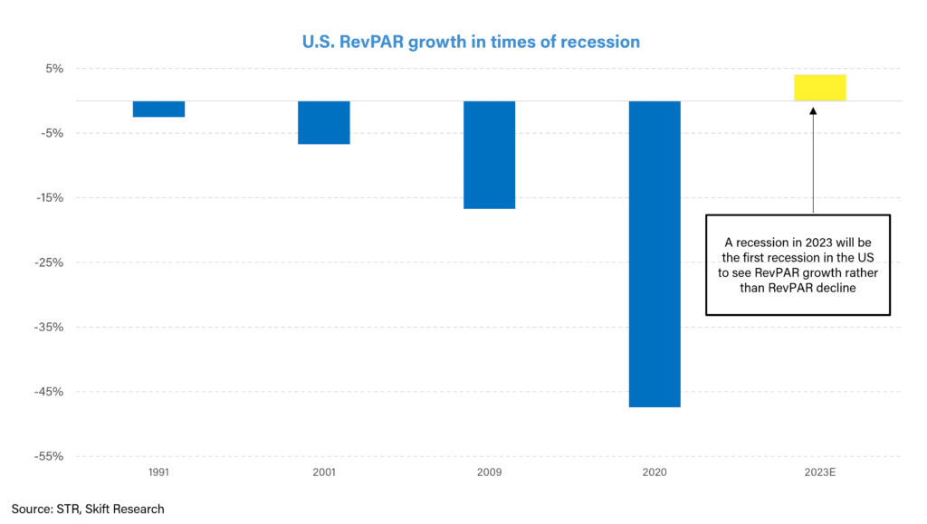
Unlike other recessions, where occupancy and ADR recover in pace with each other, the Covid recovery has seen ADR lead occupancy, as shown in the chart below. In 2022, ADRs were above pre-pandemic levels, but occupancy still below, meaning that even as we enter a potential recessionary environment, there is still scope for demand recovery – and with that comes further ADR growth.
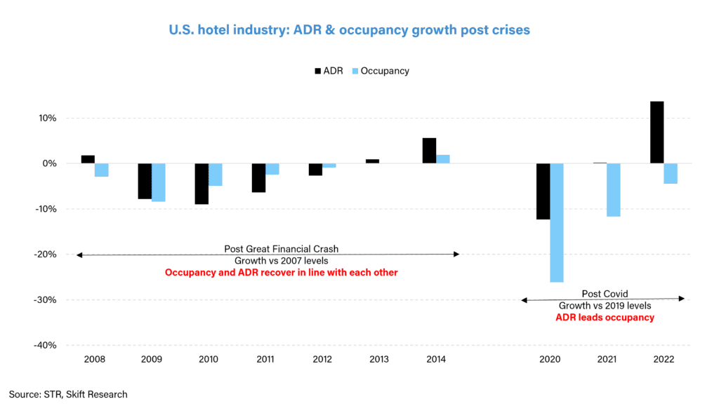
Hilton’s CEO Chris Nassetta is often quoted as saying that “the laws of economics are alive and well”, explaining that pre-pandemic: “There was no compression. You were in an environment where, while supply wasn’t high, it was over 30-year averages. And more importantly, demand was low because you were in this very low growth environment where GDP was oscillating between 0% and 2%. And supply and demand were in equilibrium – and that doesn’t give you pricing power.”
Post Covid, the supply and demand dynamic is very different, with very low levels of supply in the U.S. market, met by strong and robust demand amidst a high inflationary environment – all contributing to strong ADR growth rates. Hyatt’s CEO Mark Hoplamazian has echoed Hilton’s Chris Nasetta in saying that: “Supply growth has slowed, period, end of story. And usually, in a simplistic way, when demand exceeds supply, you have sustained pricing. And I do believe that demand will continue to outshine supply.”
However, as we enter a more normalized post-Covid world, with easing inflationary pressures and increased levels of capacity re-entering the system, we should see a more balanced recovery between occupancy and ADRs. As occupancy levels fully recover and surpass pre-pandemic levels, we expect ADRs to grow in line with demand. This means that on an absolute dollar level we expect ADR to grow even as we enter a period of recession, but on a year-on-year growth basis, we expect a slowing pace of ADR growth in 2023 vs 2022.
Executives of the major hotel brands at Q4 2022 earnings corroborated the view that ADR growth rates are expected to moderate into the second half of 2023, with growth now stemming equally from occupancy and ADR. Wyndham’s CEO Geoffrey Ballotti said that: “From a macro perspective, in the U.S., we began to lap more normalized comps in the second half of 2022. We were seeing about 3% year-over-year growth, so we’re expecting a continuation of that trend into 2023. And internationally, where not all markets are yet recovered to the pre-pandemic levels, there’s a bigger year-over-year growth opportunity. So we’re expecting all of our international regions, with the exception of Asia Pacific, to get pretty close back to 2019 occupancy levels. So overall, we’re looking for about half of our growth to come from occupancy recovery and the other half to come from some modest ADR growth.”
IHG’s Chief Executive Officer Keith Barr also expects growth rate of ADRs in leisure-skewed hotels to slow down in 2023, saying: “There’s been a significant rate push in leisure [with leisure ADRs in the U.S. 14% ahead of 2019 levels in Q4 2022; this level of rate growth is probably not going to be replicated moving forward, but it can be maintained.” However, he also expects to see further pricing growth in groups, meeting and events, and business travel, which are parts of the business with room nights still below pre-pandemic levels, noting that: “In our corporate negotiated rates, which is what we do centrally, we’re seeing kind of mid- to high single-digit pricing movement in 2023, and it’s a good portion of our overall business. So you would expect to see further pricing power in groups, meetings and events, and in business transient, whilst [pricing power] is probably coming off in leisure to some degree, not going backwards, but not seeing the same level of growth. But overall, strong pricing [for 2023].”
Further analysis of ADR growth by chain scale shows that it is luxury hotels leading pricing growth across the industry, with luxury prices up more than 20% compared to 2019 levels, versus 10-15% above 2019 levels for the other chain scales, as shown in the chart below.
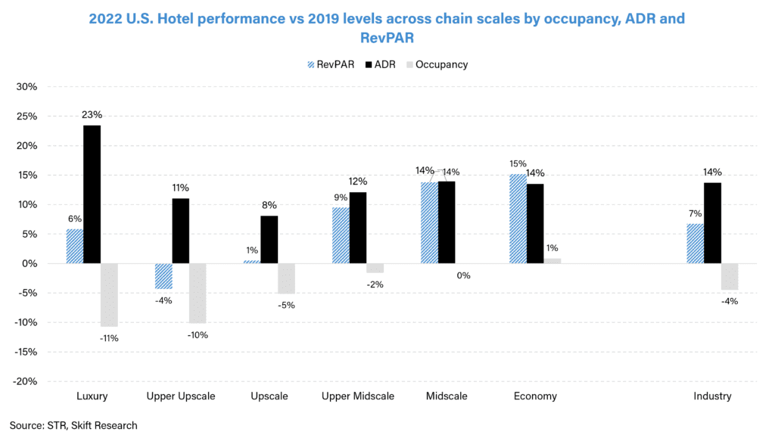
Luxury tends to be a pro-cyclical chain scale, positively correlating with economic cycle fluctuations – underperforming the market during economic downturns and outperforming during upturns. As can be seen in the chart below, during the 2008 GFC, luxury hotels, being the most discretionary of chain scales, saw the steepest ADR decline; however during the Covid recovery luxury hotels exhibited high pricing power as they benefited from huge pent-up demand and high savings rates which allowed leisure skewed luxury resorts in particular to rapidly raise prices in response to high demand within a compressed market.
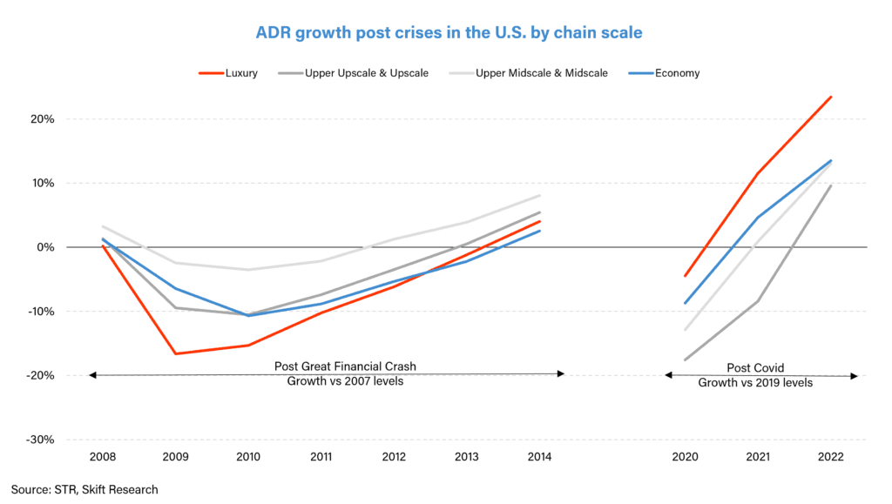
Matt Schuyler of Hilton expects luxury demand to stay resilient in 2023, saying: “We see strong demand across all segments, including luxury. And it’s this phenomenon of if I’m going to spend discretionary funds or savings on something, it’s not going to be a thing anymore. It’s going to be an experience. And then there’s the decision tree within the experience that’s really largely based on stay occasions. And if I want that trip of a lifetime at a luxury property, I’m willing to spend on it right now. And we see resiliency in this regard where people are still planning the trips of a lifetime and they want those to be in the upper upscale or luxury type properties that we offer around the world. We see growing demand in terms of the footprint of those properties where owners and developers are interested in adding more luxury properties across the world.”
Luxury pricing strength is also reflected in the outperformance of gross operating profit margins of luxury hotels compared to pre-pandemic levels. Strong ADR growth at luxury hotels has more than offset high cost inflation in 2022 and has resulted in margins at ultra-luxury hotels to more than double compared to 2019 levels, as shown in data below from market analysis and benchmarking company HotStats.
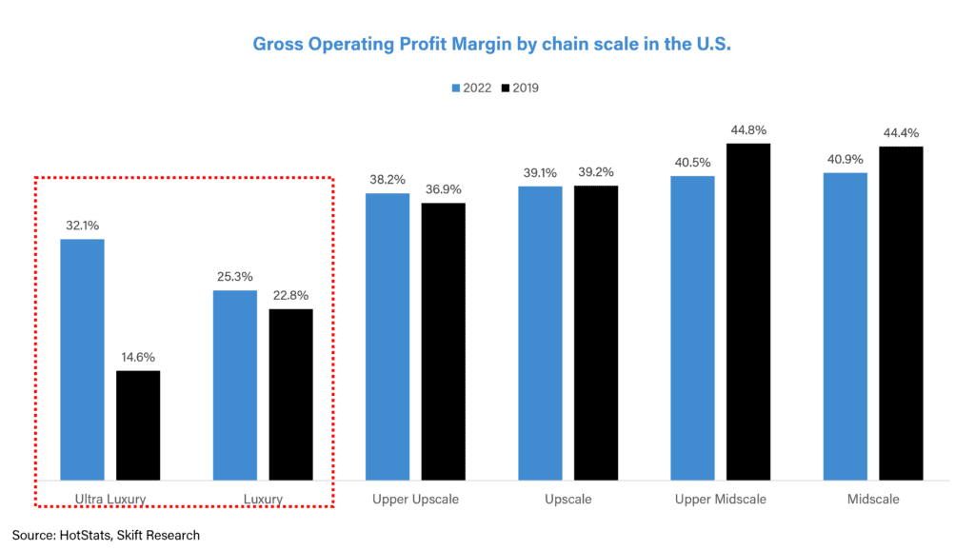
Resorts and other full-service hotels have also surpassed their 2019 margin levels based on strong pricing growth, as shown in the chart below. For example, Marriott at their Q3 2022 earnings calls commented that profit margins at their full-service hotels were up 200 basis points (i.e. 2%) compared to 2019 based on “strong RevPAR performance [note than RevPAR = ADR x Occupancy] and really strong efforts on the cost containment side”.
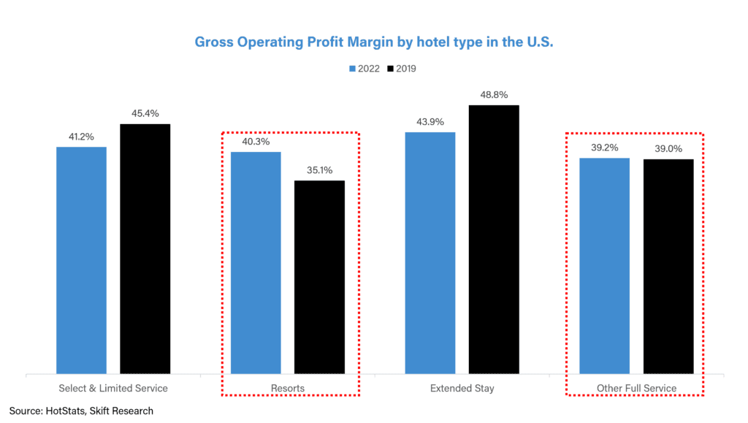

Luxury Strength is Here To Stay
Luxury will be the key differentiator when comparing a potential 2023 recession to prior downturns. Whilst we have seen luxury outperform the industry through the Covid recovery, the key question is whether this strength can be sustained as we enter a recessionary environment. We believe there are several structural reasons for luxury RevPAR to stay resilient.
Through 2022, we have seen that across the chain scale, luxury prices have risen the most versus pre-pandemic levels (luxury ADR is +23% above 2019 vs industry average of +14%), but occupancy levels at luxury hotels are still the least recovered (luxury occupancy is -11% below 2019 vs industry average of -4%). The tight labor market in the U.S. and Europe last year forced many hotels, particularly in the full service luxury segment, to place caps on occupancy in order to maintain high levels of service and access to amenities as expected from a luxury hotel.
Luxury hotels, unlike midscale and economy, are also more reliant on international travelers and this, in addition to staff shortages, has caused luxury occupancy to lag other chain scales. Alex Schellenberger of Accor, said that: “Luxury hotels in Paris, for example, can operate at this point in time probably at 70 to 80 percent capacity because of staff shortages […] Half of the reason why occupancy is still down [versus 2019 levels] is from staff shortages and half from demand being down [versus 2019 levels].”
In the near term, though the tight labor market is easing, staff shortage is still a big issue in hospitality with Dimitris Manikis of Wyndham saying that: “I don’t think that suddenly we’re going to discover millions of people who are gonna work in hospitality. I think as a business, as an industry, we missed a huge opportunity to make hospitality an industry that young people want to work in. And I think to some extent in central markets, we might have missed that train completely. So I don’t believe that the labor crisis is gonna be resolved very soon”.
High levels of compression, particularly in luxury, are expected to continue and this should contribute to sustained pricing power. Demand for luxury is also expected to remain strong despite fears that Covid stimulus checks have been spent and consumer savings depleted. A consumer survey from equity research analysts at Cowen below shows that more than half of high income earners have seen their savings increase in January 2023. This in addition to returning demand from international travelers, particularly those from Asia, provide further tailwinds for pricing expansion in luxury hotels.
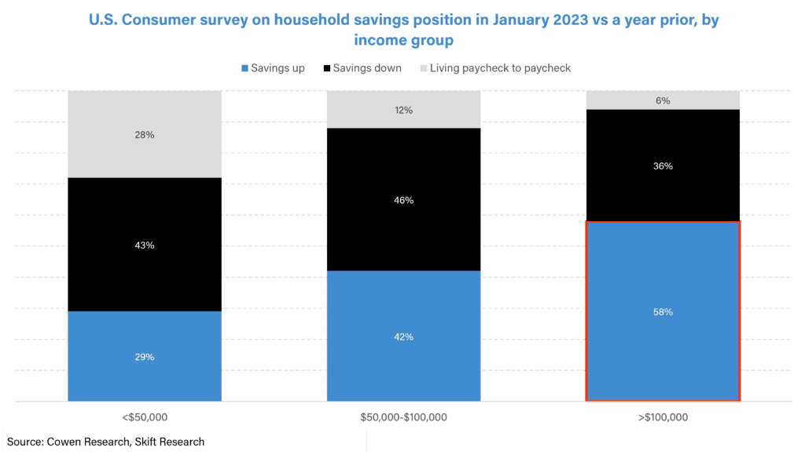
Additionally, there have been concerns that as inflation rates moderate in the second half of 2023, hotel pricing will also fall. Whilst ADR growth of 10-15% across the non-luxury chain scales has been in line with 2022 inflation rates, luxury, with ADR growth >20% above 2019 levels, is the only segment to see any real pricing growth above inflation levels.
This suggests that non-luxury hotels are still yet to see any real price increases versus pre-pandemic levels and we can expect further pricing expansion, with Wyndham’s CEO Geoffrey Ballotti reminding investors at Q4 2022 earnings of the “constant messaging that real ADR for the select-service space [which tends to skew to non-luxury chain scales] remains essentially flat to where it was four years ago.”
For the luxury segment however, we believe that the pandemic has provided an opportunity for luxury hotels to play catch-up on pricing growth which had stagnated post the GFC. Analysis from Bernstein’s global hotels and OTAs analyst Richard Clarke below shows that luxury pricing as a percentage of upper upscale remained muted for several years post the GFC, and it is only now that luxury pricing has caught up with the pre-GFC growth trajectory we should have seen, had there been no recession in 2009. This suggests that luxury prices are here to stay. We have written about this in further detail in this Skift article: Luxury Hotels May Be Underpriced Relative to Other Luxuries
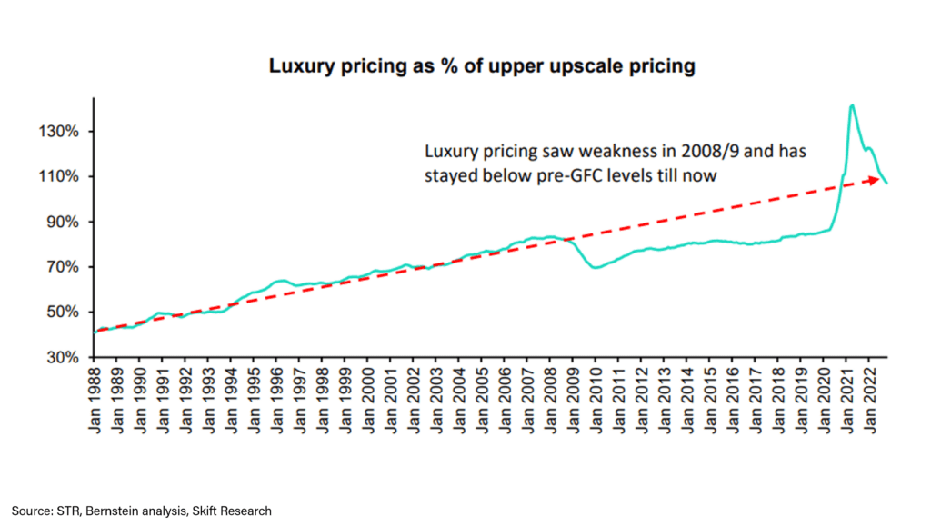
There is also much more pricing discipline in the hotel industry than there was a decade ago, with hotel managers leveraging more sophisticated revenue management technology and data analytics to maintain pricing power and prevent rate leakage. At Skift’s Global Forum in September 2022, IHG’s Chief Executive Officer Keith Barr noted: “I think this industry has gotten very, very smart about pricing […] The industry is very, very disciplined in saying, we have a level of demand, we’re still seeing sequential recovery, and we think that those rates are going to be maintained.” He further commented on the structural shift that has taken place in terms of IHG’s software capabilities, noting that: “We’ve spent well over $300 million in the recent years investing in our technology platforms. […] We just implemented a new demand forecasting model, which leverages next generation AI, and it’s looking at the historical performance of the hotel in the market, what we’re seeing from demand, but it’s also pulling in third-party data now, so what’s actually happening out with your competitors in terms of pricing. Are there special events happening in the marketplace? Over time, we’ll put more and more third-party data into that so it gets smarter and smarter and helps our hotels price more effectively”.
We remain optimistic that luxury pricing can continue to expand, in line with the demand recovery. Having said that, as inflation levels moderate this year, we don’t expect the sky-rocketing levels of pricing growth seen in 2022, instead expecting growth rates to stabilize in the second half of 2023.
We also expect upper upscale hotels, which are hotels one chain scale below luxury, to show strength in 2023. This will primarily be led by the recovery of corporate group travel which upper upscale hotels over-index to, with Matt Schuyler of Hilton saying that “Upper upscale is where all the big group room products are, where we have all the meeting space. And Group isn’t all the way back yet, but is trending up. And so I think as the year pans out, you’ll see a strengthening of that index, relative to the type of need that those hotels fulfill.” We are beginning to see groups ramp up in the recovery, with Hilton’s group RevPAR seeing the biggest quarter-on-quarter improvement in Q4 2022, recovering above 2019 levels for the first time since the pandemic.
Our expectation for continued strength in luxury and upper upscale is corroborated by forecasts from STR and Tourism Economics, as displayed in the chart below, which show that luxury and upper upscale hotels in the U.S. are expected to see the biggest growth in 2023 and 2024, led by strong demand and sustained pricing for high-end travel, despite a looming recession.
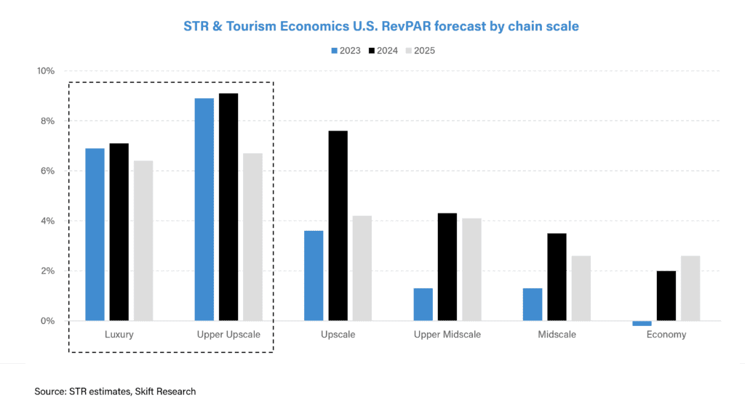

Asia is Likely to Also Show Strength In Luxury, Similar to the U.S. and Europe
Much of the analysis thus far has been focussed on the U.S. market. Accor, the most geographically diverse of the major hotel brands, provides RevPAR data by chain scale across its reported geographies, as shown for its luxury and upscale hotels in the chart below. Similar to what we have seen in the U.S., ADR as compared to 2019 levels has significantly led occupancy, and we expect sustained pricing power as occupancy levels recover to pre-pandemic levels. Accor’s luxury and upscale hotels in Asia have seen modest ADR pricing growth when compared to other regions, though still materially above 2019 levels, and we expect Asia to follow a similar playbook to the U.S. and Europe in its recovery – with luxury hotels outperforming other chain scales, benefitting from huge pent-up demand and high consumer savings.
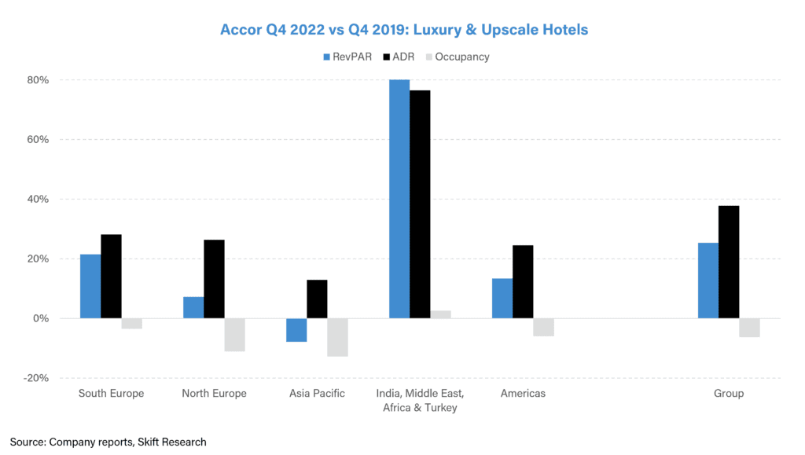

Hotel Brands Are Pushing into the Luxury Space
We have spent much of this report discussing the operating performance of hotels during periods of recession. Now let us dive into supply growth across the chain scales where opportunities lie mostly in luxury and midscale/premium economy.
In the period between the GFC and Covid, development of branded hotels skewed to upscale and upper midscale hotels. As per data from STR, in 2019, upper midscale hotels were 27% of all branded hotels in the U.S., growing share from 24% in 2007 (i.e. pre GFC), as shown in the chart below. Luxury hotels on the other hand have remained at just 3% of U.S. branded hotels since 2007. Post the GFC, hotel developers were looking for reliable, safe projects and the resilience of upper midscale during the GFC attracted owners to further push into this segment.
Mainstream select-service hotels which sit in the upper midscale segment also offer higher margin, greater return to owners and take less time to build versus their upper upscale and luxury counterparts, with Alex Schellenberger of Accor noting that “midscale hotels are much easier to scale, much easier to industrialize, and also much easier to sign, whilst it takes a far longer period for an owner to build a new Raffles or Fairmont [two of Accor’s luxury brands].” Upper midscale is also in a sweet spot within the chain scales, with low costs to build but at a higher price point than midscale hotels, thus offering higher return on investment for hotel developers.
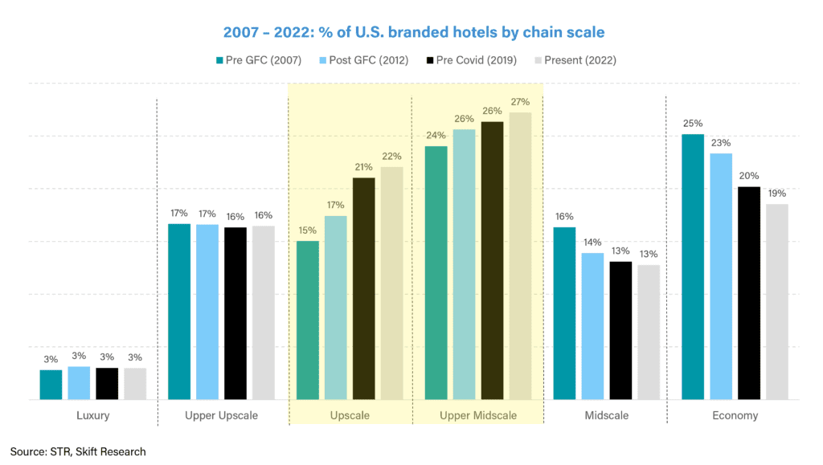
As shown by construction pipeline data from January 2023 in the chart below, upscale and upper midscale will continue to take share, accounting for 32% and 34% of total rooms under construction respectively, versus their current share of 22% and 27% respectively. However, unlike the period after the GFC, the luxury segment is also expected to take share, doubling its share of rooms from 3% of current rooms to 6% of rooms under construction.
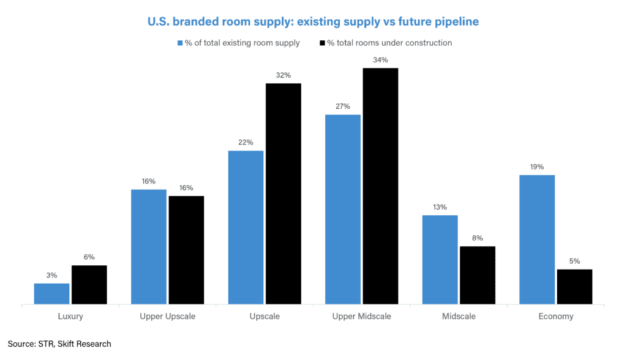
If we consider rooms under construction as a percentage of existing supply, we can see that luxury hotels are being constructed faster than any other chain scale, as shown in the chart below, spurred on by the outperformance of the luxury segment in 2022, with Matt Schuyler of Hilton saying that “People are still planning the trips of a lifetime and they want those to be in the upper upscale or luxury type properties that we offer around the world. We see growing demand in terms of the footprint of those properties where owners and developers are interested in adding more luxury properties across the world.”
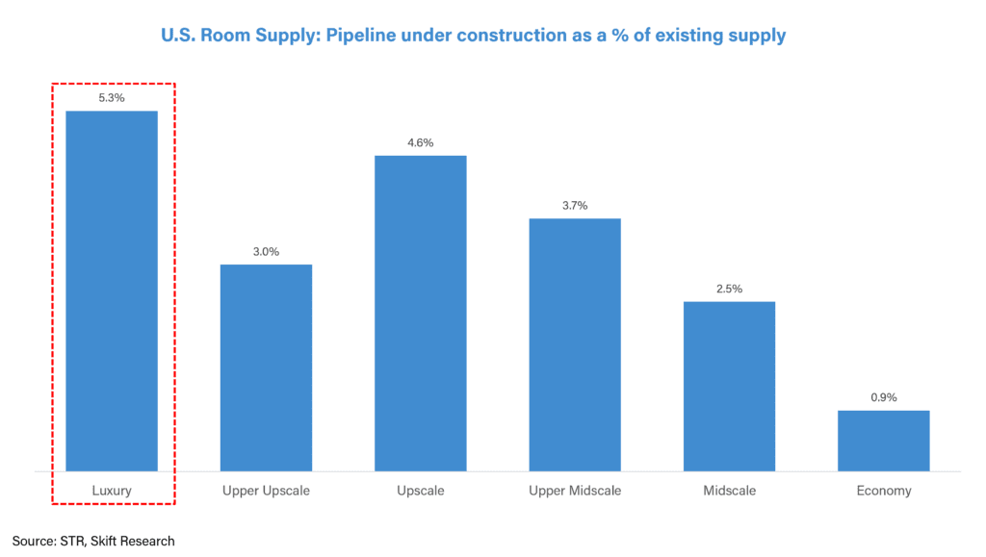
Brands are pushing further into the luxury space – globally, branded luxury rooms account for 6% of the total branded supply across all the chain scales, but 8% of the pipeline, with majority of growth coming from luxury resort hotels in Caribbean & Mexico and from Asia Pacific, as shown in the chart below. At Q4 2022 earnings, Hyatt management said that in 2022, 66% of their gross room additions were in the luxury, lifestyle, or resort properties, with “nearly 135,000 luxury lifestyle and resort rooms now part of our portfolio, a number that is larger than the entirety of our portfolio just a decade ago”. IHG management said that their luxury and lifestyle estate represents 13% of their existing rooms, but 20% of the pipeline, suggesting further expansion in the luxury space. Accor has said that luxury “which is always getting a larger share of the pipeline” accounts for 40% of the pipeline (as of Q3 2022 earnings), having grown from 25% of the pipeline 4 years ago.
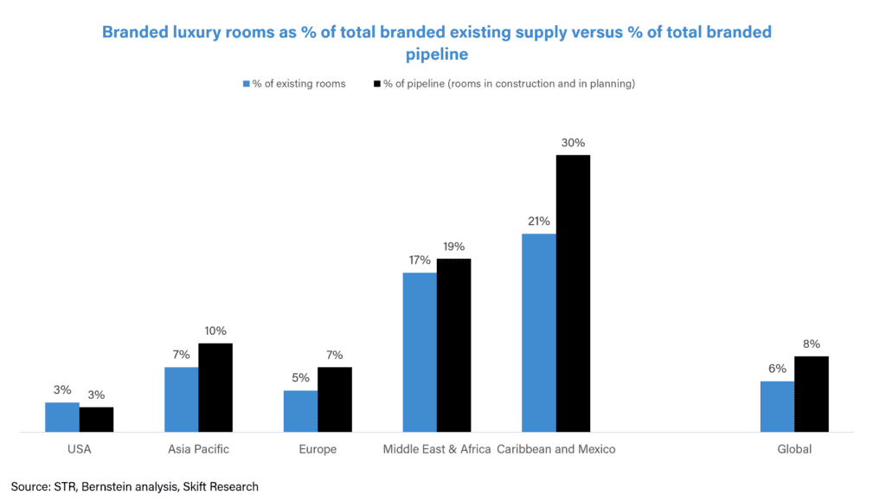
Data from JLL Hotels & Hospitality Group below shows that there has been increased interest from investors in the luxury hotel sector, with property transactions for global luxury hotels in 2022 5% higher than 2019 levels. JLL expects a material boost in 2023 from China’s re-opening, with China historically contributing $900 million annually to cross-border luxury hotel investment, none of which has been invested since early 2020. JLL also expects traditional luxury brands to expand into non-RevPAR related verticals such as luxury yachts and private membership clubs, ‘which will present increased investment opportunities’.
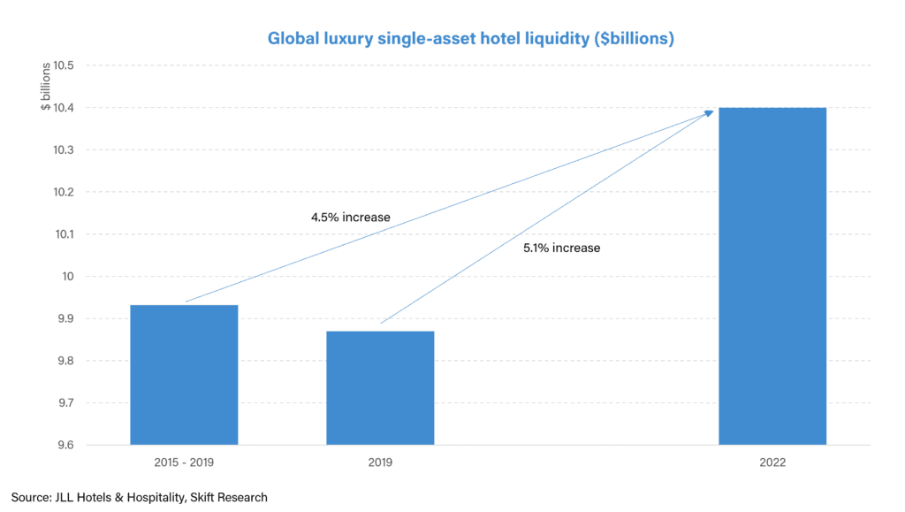

Luxury and midscale/premium economy offer the greatest opportunity for share gains
In addition to luxury, the other great whitespace opportunity is in midscale or premium economy.
Market share analysis of the branded hotel room supply by chain scale, as displayed in the chart below, shows that whilst upper upscale, upscale, and upper midscale segments are largely saturated, with the major hotel brands already having 90% market share, it is the luxury, midscale, and economy segments which offer the greatest whitespace opportunity for share gains.
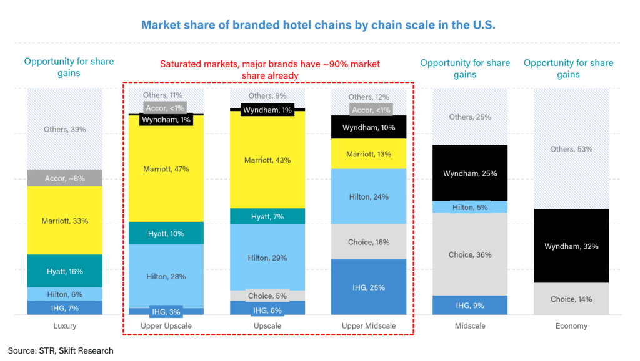
In recent months, we have seen a flurry of new brand launches in these opportunistic segments. In the midscale/premium economy space, which Dimitris Manikis of Wyndham Hotels has called “a segment too important to ignore”, many hotel chains have launched their first conversion brand in this segment such as Hilton with its new conversion brand Spark. Chris Nassetta, CEO of Hilton has said that “Premium economy represents a large and growing segment of travelers, totaling nearly 70 million annually in the U.S. alone […] It’s the biggest segment in the U.S. It’s the biggest segment in Europe.” Matt Schulyerof Hilton further added that “40% plus of the U.S. hotel industry is in this premium economy space. And we don’t have a product there. And yet we think we can now because the consumer is evolving to seek value. And post pandemic travel is important for a big part of the consumer. Value for money is important. You marry these two together and having a product in the economy sector makes a lot of sense.” Other major brands have also expanded into this segment, with Marriott acquiring City Express in the Caribbean and Latin America and Accor launching Handwritten Collection. In luxury, in 2021, Accor launched a new conversion brand called Emblems and IHG launched Vignette Collection.
The majority of these brand launches have been conversion brands. Conversion activity has been elevated through the Covid recovery, as independent hotels look to the big brands as a flight to safety and quality during a period of economic uncertainty. Many of the major brands already have conversion brands in the luxury/upper upscale space but not in the upscale and lower segments. However Matt Schuyler of Hilton expects “conversions to make their own way down the chain scale and you’ll see more of this in the future, not less”, adding that “conversions are a healthy way of going about gaining scale and extending your footprint [and] as the market evolves and as [owners] look to either extend the life of their existing product or turn it into a meaningfully different offering to a consumer set, this is where conversions come into play.”
As well as going after the white-space opportunities in the market, the major hotel brands are also building out their portfolios to be more diverse across the chain scales. For example, before launching Spark, Hilton had no exposure in the premium economy space, but Chris Nasetta, CEO of Hilton now expects Spark to be “the biggest brand we have in terms of number of units”, saying that “in terms of an opportunity to be a value contributor in the billions of dollars for this company and its shareholders, I’m as excited about this as anything else we’ve done.” It is also a matter of scale, with hotels in the midscale and economy segment able to join the network far quicker than luxury hotels, with Matt Schuyler of Hilton saying that “At the luxury end of the chain scale, you have maybe a couple hundred hotels. That’s the upper end of the chain scale. The lower end you have thousands of hotels, simply because of the scale that you can command. So the high percentage of growth in luxury is relative to our hundred hotel footprint, whereas at the lower end of the chain scale we have thousands of Hampton Inns.”
Whilst Hilton, Marriott, IHG, and Accor are diversifying their portfolios by expanding into the midscale segment, where they under-index to, Wyndham and Choice are expanding more upscale, with Choice recently acquiring Radisson Hotel Group Americas, which skews more upscale compared to their current portfolio. It makes sense that large hotel chains will go after the gaps in their portfolios, with Choice, in regard to their Radisson acquisition, saying that it is an opportunity to “bring the company’s best-in-class franchising platform to adjacent hotel segments and to a new set of hotel owners.” We can certainly expect further growth and acquisitions in both luxury and midscale/economy from the major hotel brands going forward.

Who Will be the Winners in 2023?
Our bull case scenario is that luxury will show strength even in the face of a potential recession, unlike what has been seen in previous downturns. Luxury hotels in Asia Pacific are likely to see the biggest uplift, benefitting from huge levels of pent-up demand for high-end hotels as we have seen in the U.S. and Europe last year. In this scenario, we would expect Hyatt to outperform peers, being the most exposed to luxury and to Asia Pacific among the major hotel brands, whilst Wyndham and Choice, being largely U.S. focussed have fewer opportunities for recovery-led growth in 2023. This can be seen in the full-year 2023 RevPAR guidance given by the companies, with Hyatt guiding to 6-11% year-on-year RevPAR growth in 2023, versus Choice guiding to domestic RevPAR only growing 2% in 2023.
However to the extent that we are wrong and we see a 2023 recession following a similar pattern to previous recessions, with more traditional midscale hotels prevailing and luxury suffering the most; we would expect IHG, Wyndham and Choice to offer the most protection, based on their chain scale exposures to upper midscale and midscale hotels. Hilton and Marriott, being the most exposed to upper upscale hotels which typically skew to group corporate travel – a procyclical segment – are likely to show less resilience in this bear case scenario. However Hilton and Marriott are also very good at converting owners to join the branded network and they can utilize their powerful loyalty systems to quickly push into the premium economy/ midscale segment through soft brands – as they have recently done with the brand launches of Spark by Hilton and City Express by Marriott respectively.
Lastly, in a mixture of our bull and bear case scenario, where leisure travel stays strong, the rich remain rich but we see more trading down at the lower end of the market; we expect Accor, being the most diverse hotel brand across geographies and chain scales, to benefit the most from both luxury outperformance in Asia Pacific and midscale resilience in Europe.
